Year 2 – Maths arithmetic practice
Q1.

5 + 10 + 5 = | 
Q2.

80 − 10 =
Q3.
80 ÷ 10 =
Q4.
15 + 3 + 3 = | 
Q5.
20 + 30 + 50 =
Q6.

+ 8 = 20
Q7.

16 − |  | = 10
Q8.

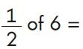
Q9.

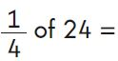
Q10.
